Basic Salary: $

*Please ensure that you run through the information within the biodata as it is an important document to help you to select a suitable FDW.

PROFILE OF FDW (BIO-DATA OF FOREIGN DOMESTIC WORKER (FDW))

A1 Personal information

- Name: Kyin Wine

- Date of Birth:
Age:
- Place of Birth:

- Height & Weight:
cm
kg
- Nationality:

- Residential address in home country: .
- Name of port / airport to be repatriated to:

- Contact number in home country:

- Religion:

- Education level:

- Number of siblings:

- Marital status:

- Number of children:

- Age(s) of children (if any):

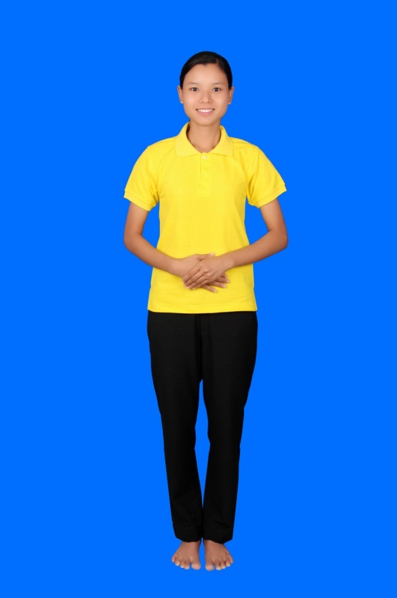

21.6.1997 26

Ngaputaw

157 50

Myanmar

Ngaputaw,,Ayayewaddy

Yangon International Airport

Buddish

9 Standard

4

Single

- Allergies (if any) :

- Past and existing illnesses (including chronic ailments and illnesses requiring medication):

 | Yes | No | Yes No
i. Mental illness |  |  | vi. Tuberculosis
ii. Epilepsy |  |  | vii. Heart disease
iii. Asthma |  |  | viii. Malaria
iv. Diabetes |  |  | ix. Operations
v. Hypertension |  |  | x. Others: Nil

- Physical disabilities:

- Dietary restrictions:

- Food handling preferences: No Pork No Beef Others:

A-1

A3 Others

- Preference for rest day : rest day(s) per month.

- Any other remarks:

SKILLS OF FDW

B1 Method of Evaluation of Skills

Please indicate the method(s) used to evaluate the FDW's skills (can tick more than one):
Based on FDW's declaration, no evaluation/observation by Singapore EA or overseas training centre/EA Interviewed by Singapore EA
Interviewed via telephone/teleconference Interviewed via videoconference
Interviewed in person
Interviewed in person and also made observation of FDW in the areas of work listed in table

S/No | Areas of Work | Willingness Yes/No | Experience Yes/No  If yes, state the no. of years | Assessment/Observation  Please state qualitative observations of FDW and/or rate the FDW (indicate Nil of no evaluation was done) Poor............Excellent. Nil  1 2 3 4 5 Nil
1 | Care of infants/children Please specify age range:
2 | Care of elderly
3 | Care of disabled
4 | General housework
5 | Cooking  Please specify cuisines:
6 | Language abilities (spoken) Please specify:
7 | Other skills, if any Please specify:

A-2

Interviewed by overseas training centre / EA (Please state name of foreign training centre / EA: ) State if the third party is certified (e.g. ISO9001) or audited periodically by the EA :

Interviewed via telephone/teleconference Interviewed via videoconference
Interviewed in person
Interviewed in person and also made observation of FDW in the areas of work listed in table

S/No | Areas of Work | Willingness Yes/No | Experience Yes/No  If yes, state the no. of years | Assessment/Observation  Please state qualitative observations of FDW and/or rate the FDW (indicate Nil of no evaluation was done)  Poor ...Excellent...Nil  1 2 3 4 5 Nil
1 | Care of infants/children Please specify age range:
2 | Care of elderly
3 | Care of disabled
4 | General housework
5 | Cooking  Please specify cuisines:
6 | Language abilities (spoken) Please specify:
7 | Other skills, if any Please specify:

EMPLOYMENT HISTORY OF THE FDW C1 Employment History Overseas
Date |  | Country (including FDW's home country) | Employer | Work Duties | Remarks
From | To
2016 | 2018 | Myanmar | Daw Cho Wai | Looking After Children,Cooking ,Cleaning ,and All General House Work

A-3

C2 Employment History in Singapore

Previous working experience in Singapore: Yes No
(The EA is required to obtain the FDW's employment history from MOM and furnish the employer with the employment history of the FDW. The employer may also verify the FDW's employment history in Singapore through WPOL using SingPass)

C3 Feedback from previous employers in Singapore

Feedback was/was not obtained by the EA from the previous employers. If feedback was obtained (attach testimonial if possible), please indicate the feedback in the table below:

Feedback

AVAILABILITY OF FDW TO BE INTERVIEWED BY PROSPECTIVE EMPLOYER
FDW is not available for interview FDW can be interviewed by phone
FDW can be interviewed by video-conference FDW can be interviewed in person

OTHER REMARKS

.

FDW Name and Signature Date:

EA Personnel Name and Registration Number Date:

I have gone through the 4 page biodata of this FDW and confirm that I would like to employ her

Employer Name and NRIC No.
Date:

IMPORTANT NOTES FOR EMPLOYERS WHEN USING THE SERVICES OF AN EA
- Do consider asking for an FDW who is able to communicate in a language you require, and interview her (in person/phone/videoconference) to ensure that she can communicate adequately.
- Do consider requesting for an FDW who has a proven ability to perform the chores you require, for example, performing household chores (especially if she is required to hang laundry from a high-rise unit), cooking and caring for young children or the elderly.
- Do work together with the EA to ensure that a suitable FDW is matched to you according to your needs and requirements.
- You may wish to pay special attention to your prospective FDW’s employment history and feedback from the FDW’s previous employer(s) before employing her.

A-4

